Assignment 10

10.1. a.
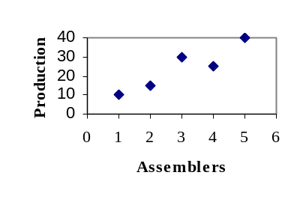
Yes, as the number of assemblers increases, so does the production.
b. =3, =24
X | Y | 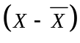 | 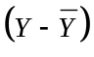 | 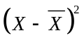 | 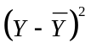 | 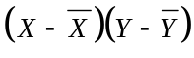
2 | 15 | -1 | -9 | 1 | 81 | 9
4 | 25 | 1 | 1 | 1 | 1 | 1
1 | 10 | -2 | -14 | 4 | 196 | 28
5 | 40 | 2 | 16 | 4 | 256 | 32
3 | 30 | 0 | 6 | 0 | 36 | 0
15 | 120 |  |  | 10 | 570 | 70

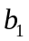=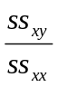=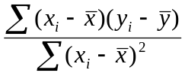=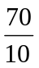=7
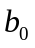=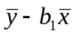=24-73=3
So the regression equation is: =3+7x.
c. 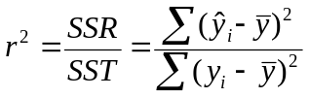=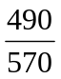=0.8596
the coefficient of correlation: r=0.9272
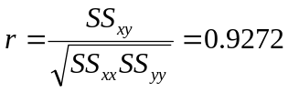
d. x=6, =3+7*6=45.

